https://github.com/OlafenwaMoses/ImageAI

pip install keras-retinanet

Ativar o ambiente retinanet instalado no anaconta

na linha de comandos executada em Administrador

cmd.exe - executar como administrador

> activate retinanet

Para compilar o Keras-retinanet:

1. baixar o retinanet do Github fazendo o download na nossa maquina

2. entrar pela linha de comandos

CMD.exe

3. Mudar de diretorio

cd\ C:\Users\Lenovo\Google Drive\UPT_Portucalense\GitHub\ML\keras-retinanet

cd C:\Users\Lenovo\ML\keras-retinanet - baixei nesta pasta o retinanet

4. fazer o buil do retinanet

python setup.py build_ext --inplace

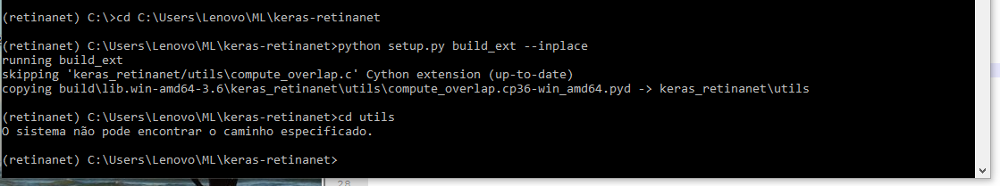

Deu erro Compute_overlap.c Cython extension up-to-date

Analise do erro:

Python on Windows requires VS Build Tools for building C/C++ extension modules.

You probably have Visual Studio Express. This is known to be broken for compiling Python C extensions on 64-bit systems. Go to <https://wiki.python.org/moin/WindowsCompilers> and follow the instructions there to select and install the correct version(s) of the Visual C++ compiler for the version(s) of Python you installed.

Upgrade do setuptools do Visual Studio

pip install --upgrade setuptools

Upgrade do phyton

python -m pip install –upgrade pip

**Only resolved problem when I run the command bellow in the retinanet directory.**

pip install . --user

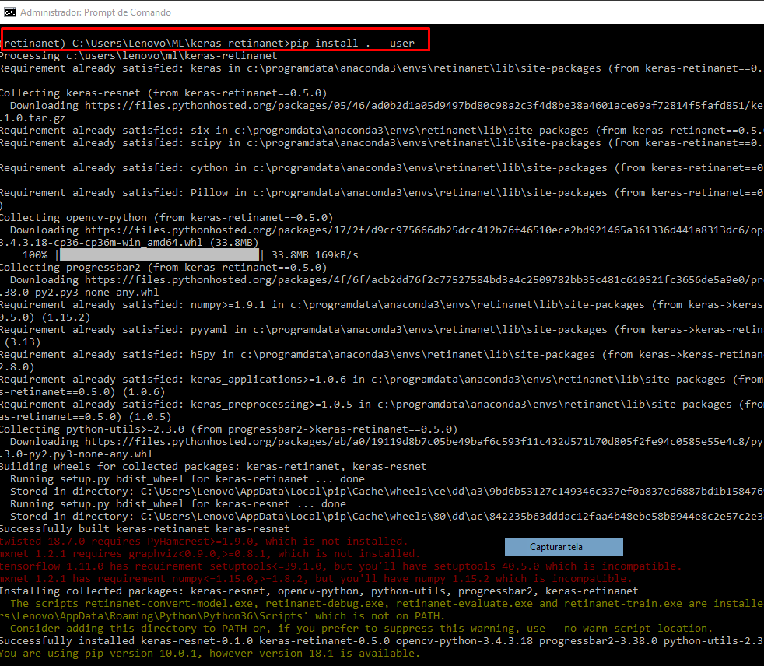

# Sobre Cython - Cython é um compilador para Python

http://docs.cython.org/en/latest/src/tutorial/cython_tutorial.html#cython-hello-world

Instalar Cython no anaconda

conda install -c anaconda cython